1) please make sure that the inside pages open when we click on the display picture of the project as well

2) after putting Marketplace, Purchases, Finance, Accounts, Ask Brokr in the sidebar (a drop-down that happens when you hover over it and stay after clicking it, please make sure that the pages switch from one to another on hovering over them in the sidebar drop down and stay when we click on them  
  
Just to Recap Previous Changes on portal

1. AED size to be smaller than the number (everywhere) (Not Done)

2. 15% installments change to Down-payment (or discuss) (Not Done)

3. Remove large-scale projects and (Done)

segregate it city-wise (Not Done)

4. When we scroll down there is a lot of projects without connection or linking it looks cluttered (Done)

5. Remove BY and add | eg Bayz | Danube (Done)

6. What do you mean by-products? Change the name to AVAILABLE PROPERTIES (Not Done)

7. Create content or harvest from brochures regarding the location and project

8. Correct the file names of brochures that are uploaded (Not Done)

9. What is Dubai/Dubai Remove duplication (Done) like marketplace, etc, and proofread the whole portal for such duplications

10. Add a bar at the end of the page that has contact, disclaimer & copyright (Not Done)

11. Backlink the map on properties (Done)

12. Why is commission & pricing the same (Done) where is the commission being viewed

13. Check each property website and tally offerings, nearby locations, and add their video and other collaterals individually (Not Done) (WIP)

14. Property names are everywhere to be

- Quatro Del Mar | RAK

- BAYZ101 | Danube

- ALJADA | ARADA

- ARMANI BEACH RESIDENCE |BY ARADA and so on

15. 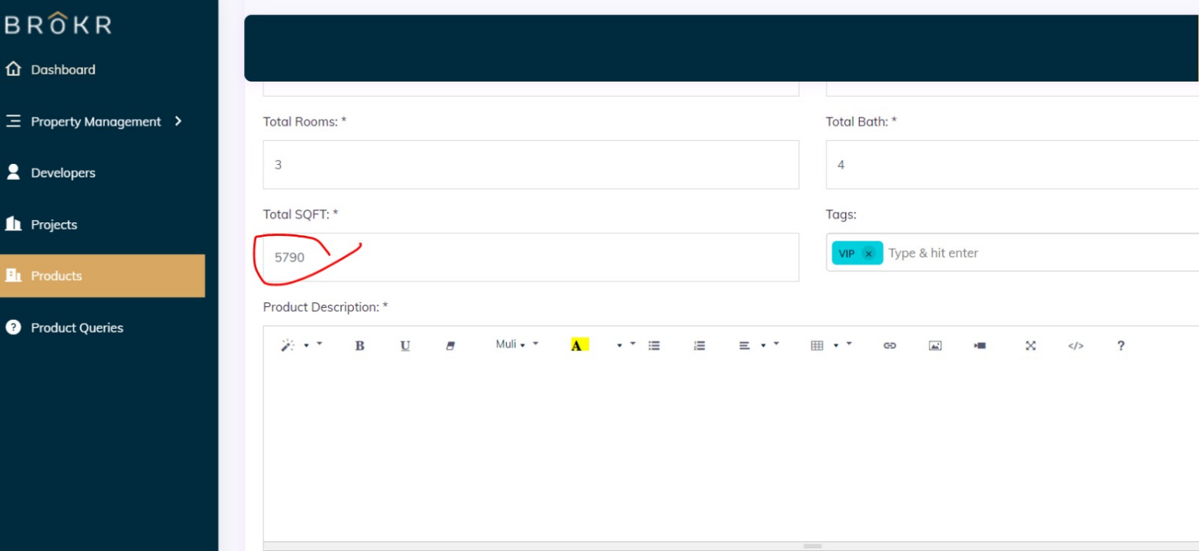

this field should allow any number, alphabet and symbols

16.



we should be able to add values of our own choice.

17.  
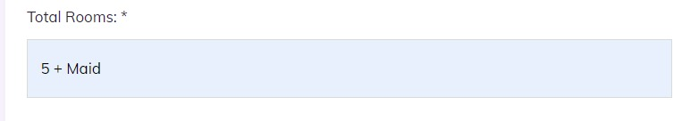  
we should be able to add values of our own choice.

allow admin to write all characters in this field (symbols, characters, numeric)

18. There are TWO FILTERS

1. CITY WISE ON HOME PAGE

2. PROPERTY WISE ON INSIDE PAGES